**Interactive Visualization with d3**

Michelle Carney and Shrestha Mohanty

For this assignment, we divided up the work equally:

* Radar Chart: Michelle
* Parallel Coordinates: Shrestha
* Write Up: Michelle
* Web Link: Shrestha

We both had different approaches. Michelle noticed that the Radar Chart is great for comparing overviews, while Shrestha played to the strength of the Parallel Coordinate’s ability to show trends. Our motivations were for each chart to compliment the other: the Parallel Coordinates shows the trends of each country on the university level, while the Radar Chart compares the averages of each country to different countries at once.

**Code Modifications:**

Radar Chart:

For the Radar Chart, the original d3 code supplied was used, as well as the examples from class. For additional support on how to read in the data from a CSV file, GitOnion and PDGlenn repositories were used. For updating the radar chart using buttons, Bl.ocks was used.

Michelle realized the strength of the radar chart was to display a small set of values and compare them with other categories. Therefore, she created a new data csv that took the average of the universities by country, effectively showing the average teaching, income, research, citation, and overall score of the universities in each country between 2011-2016. We wanted to specifically look at these metrics as they could shed light on what values go into calculating the “overall” or total_score, and how they differ between countries. This was the motivation to show the list of all countries as buttons on the side, a way to update the radar chart and compare countries easily. We used color to capture the different countries and plot their differences, and this is reflected in the buttons pressed (the button changes color to match the radar plotted chart).

Michelle also used the Alangrafu radar-chart.js to create a tool tip that displayed the values for each country once the user mouses over. As you add other countries to the radar chart, the scales change (although the color stays consistent), and it is hard to read the values on the scale – hence the need for the tooltip to compare the values, in addition to comparing the shapes.

Alangrafu:

<https://github.com/alangrafu/radar-chart-d3>

GitOnion: <https://github.com/GitOnion/D3_Ranking_College/blob/master/index.html>

PDGlenn:

<https://github.com/pdglenn/UniversityVisualizationD3>

Bl.ocks:

<http://bl.ocks.org/d3noob/7030f35b72de721622b8>

<http://bl.ocks.org/tpreusse/2bc99d74a461b8c0acb1>

Parallel Coordinates:

Shrestha chose to work with the top 200 universities and used the code provided in class which was from Jason Davies post for the main structure of this visualization. Changes were made to represent ordinal data like the name of the country for each of the universities. Apart from the brushing and being able to slide the columns, different color codes are added to represent and differentiate between the continents where the university is located. The code for the legend is supported by <http://plnkr.co/edit/7LQUOzlUGvv9KZyLvuAp?p=preview>

This chart thus gives a good idea as to the which countries or continents have greater number of universities in the top 200 and also allows to see the overall trends and performance of the universities and countries in terms of the world ranking, and citations, teaching, research scores.

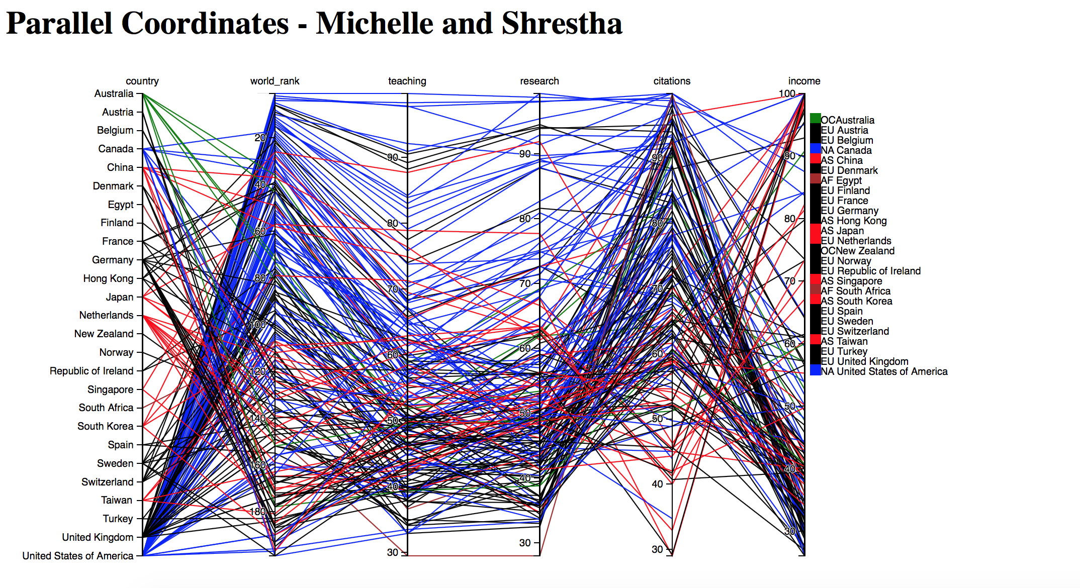

**Analysis:**

From our two visualizations, we can see that the true strength in the Radar Chart is to compare a select few parameters of different categories in broad general ways, while the Parallel Coordinates is much better at capturing general trends in the data from many parameters, which makes them complementary in our assignment. Radar charts cannot handle more than 5 parameters as they become confusing – the axes are arbitrary and the scales are not readable, which is why we spent extra time investigating how to display tooltips with the values of the parameters we are plotting. However, this lack of granularity is why they are good for relative comparisons, like between countries in our example (i.e. “Although both the UK and Portugal have comparable income scores, there are twice as many citations from UK universities than Portugal”).

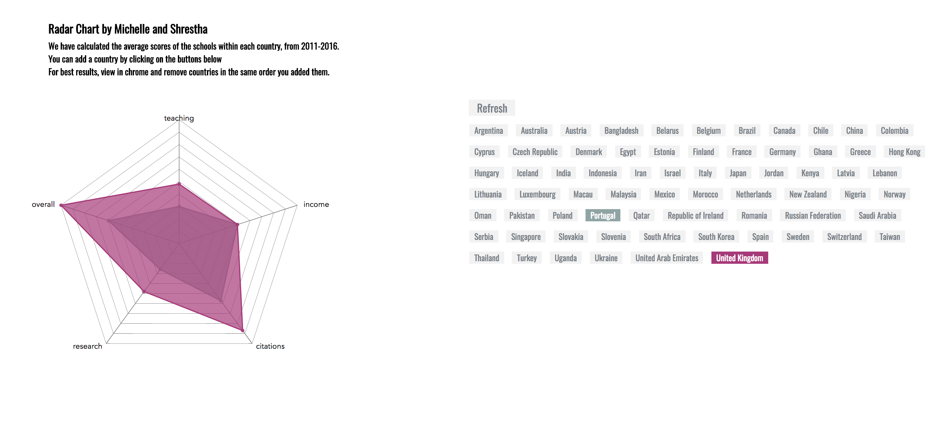

The Parallel Coordinates diagram is great for seeing trends by country – is there a single school in a country that is performing way better or way worse than its peers? Do all of the schools in one country score really well on citations, but poorly with score? Parallel coordinates can plot many different parameters, where as Radar Charts can only plot a few. However, Parallel Coordinates falls short when it comes to comparing specific countries overall, it is really great at comparing specific schools (the individual lines that come from the countries).